Human Machine Interface

A human machine interface is a is a space where human and machine interactions can occur. Its software can consist of an OS as well as an application program, where as its hardware can consist of either a microprocessor or a FPGA chipset. The software and the hardware must be compatible with one another.

What we have accomplished is constructing an LCD16x2 interface displaying temperature.

What we used (BOM):

* Temperature sensor (TEMP LM35) 9$
* RA2 3$
* Analogue to digital convertor 5.51$
* PIC18F45K50 3.45$
* 16X2 LCD 16$
* Buzzer 4.4$
* Keypad 8$
* easypic 250$

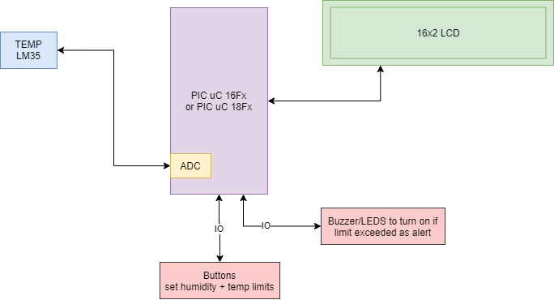

How this works is that the PIC18F45K50 is connected to the LCD (which displays the temperature, as well as the upper and lower limits) through ports. The PIC18F45K50 receives its digital signals from the ADC which receives its analogue signal from the RA2. The readings are sent to the RA2 from the temperature sensor.